**Develop a Mobile Application**

|  |  |
| --- | --- |
| Team Id | PNT2022TMID12291 |
| Project Name | Smart Farmer – IOT Enabled Smart Farming Application |

**Frontend:**

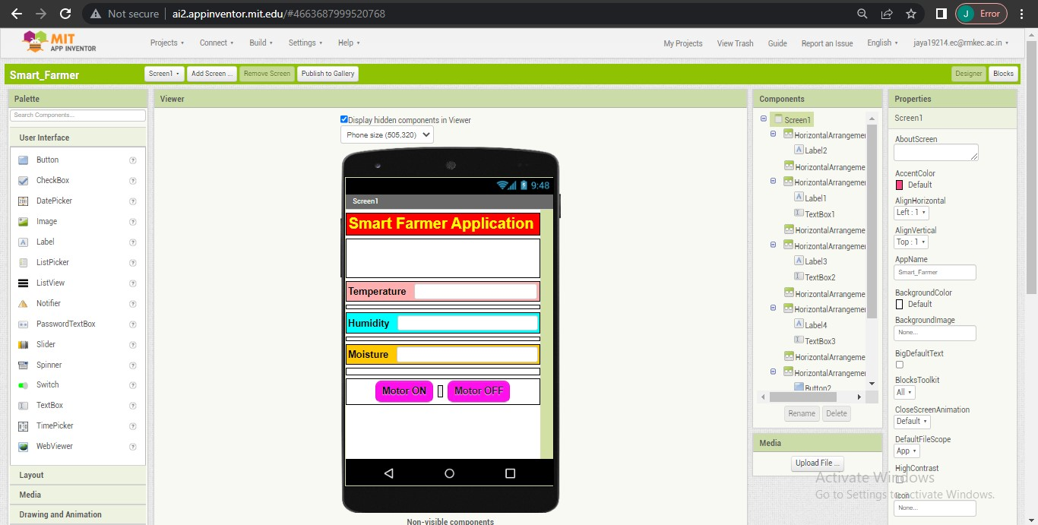

**Backend:**

